* Open in Cognito window for chrome / InPrivate windows for Edge, then login to power bi app.powerbi.com
* From Power BI make sure you understand where the tenant for power bi is created. If you are using your visual studio benefits, use the admin account to login.

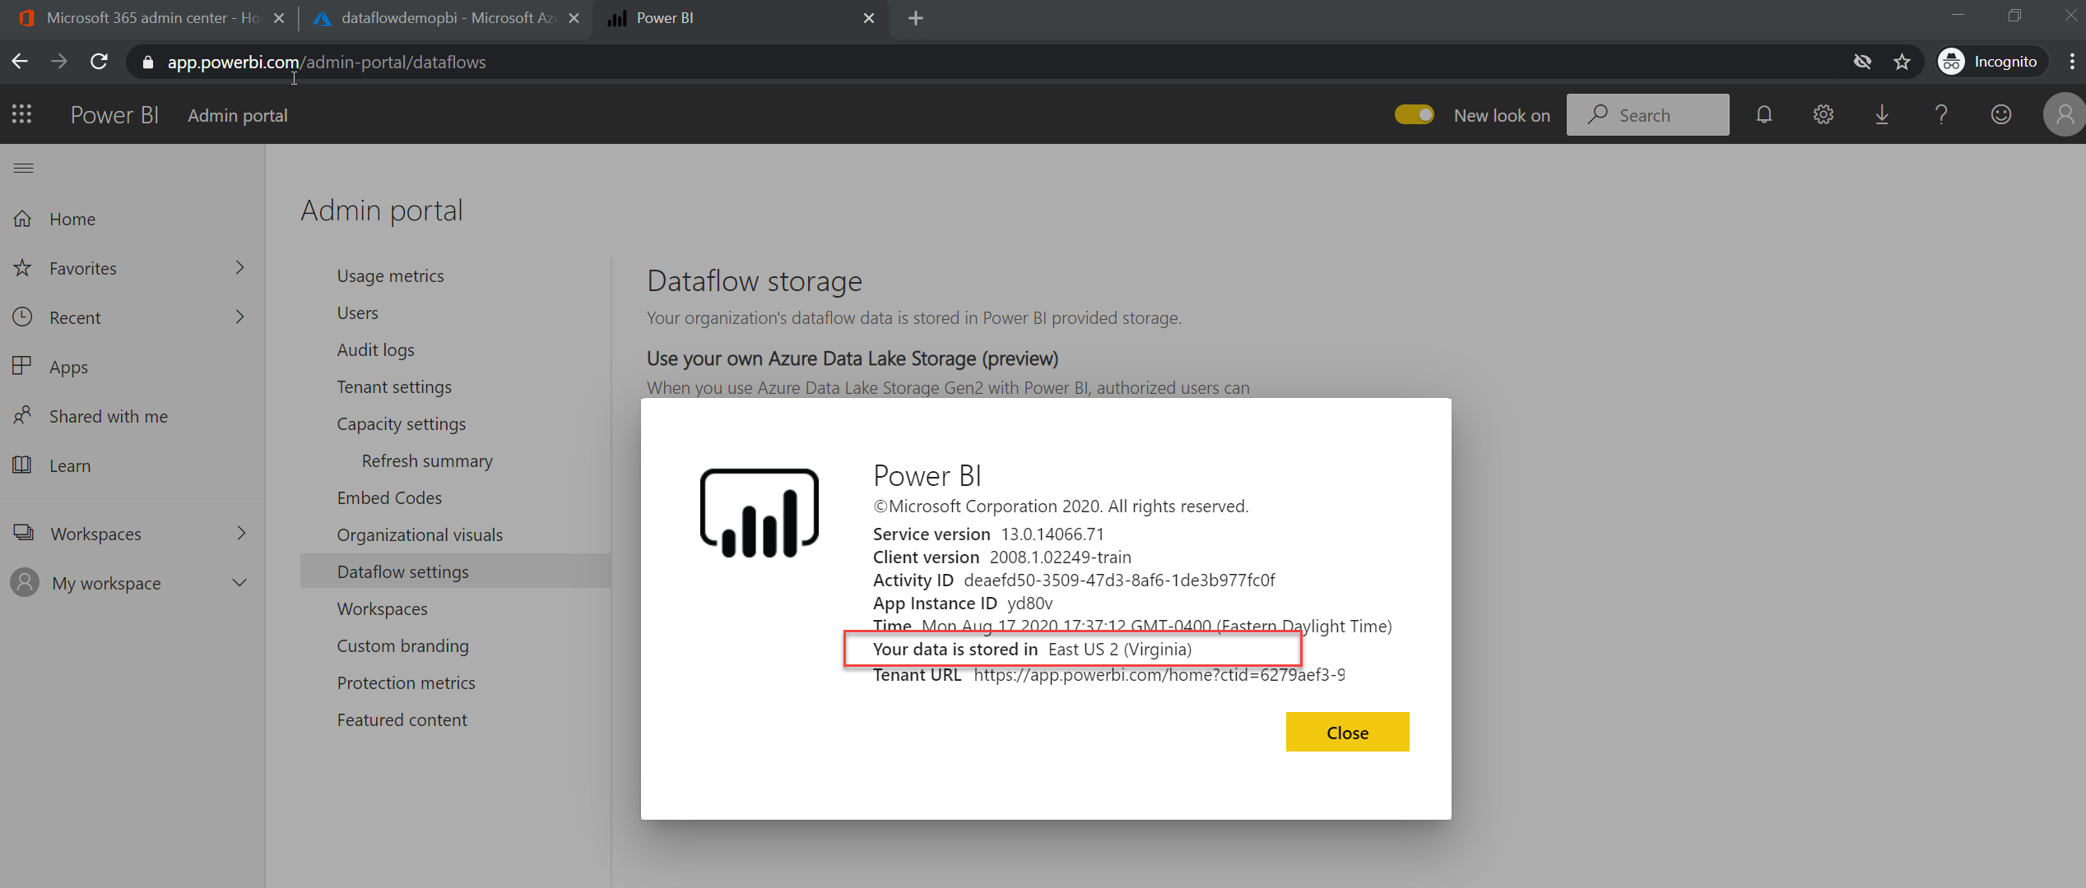

* After you understand where the data is located for power bi, login to portal.azure.com. Use the same visual studio benefit account to login. I used another tab in the previously opened window.
* Create an Azure Data lake Gen2 Account.

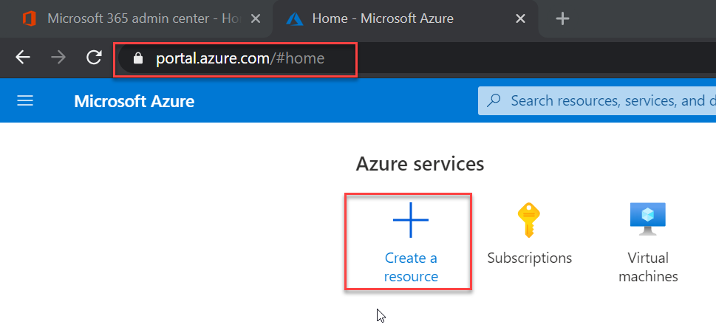

* Type Storage account from the search option and select storage account.

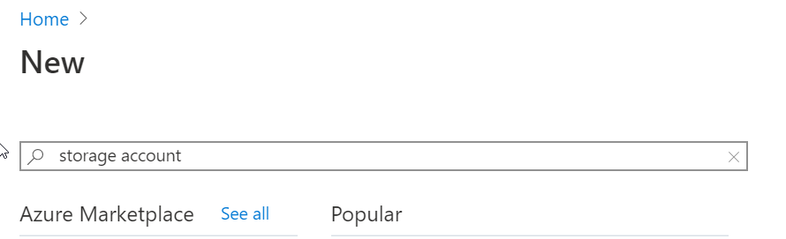

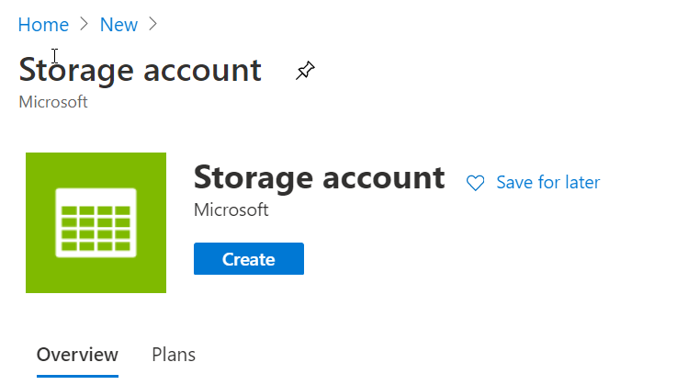

* Create a resource Group, I named it PowerBIDemo.

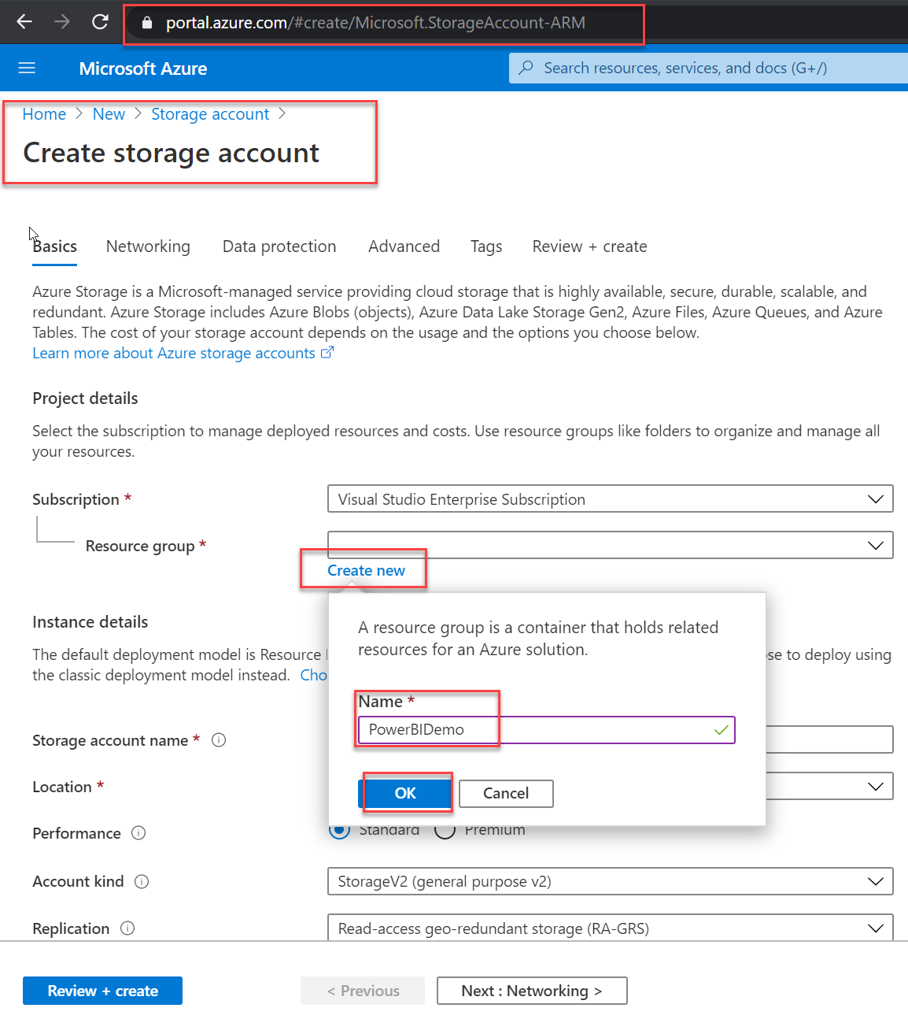

* Specified the Account Kind as Storage V2, named it as dataflowdemopbi (You can choose the name you would like). Make sure you choose the same Location as Power BI data location. Click on Next: Networking.

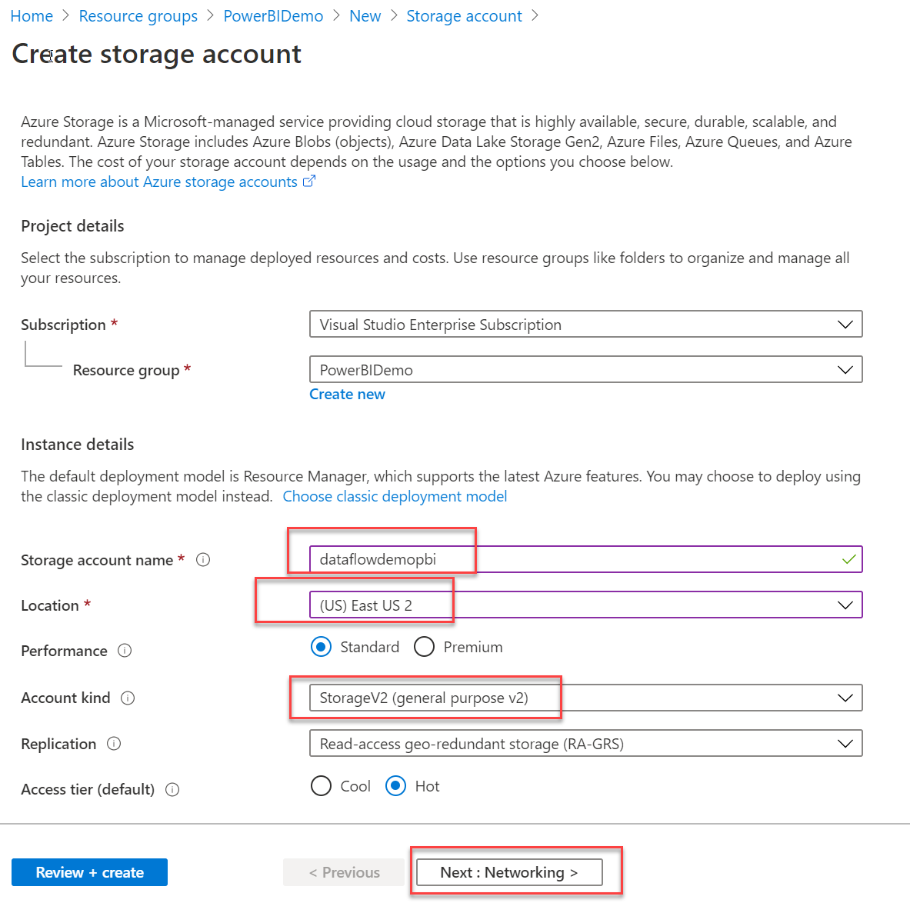

* I kept all the option default in networking and select next.

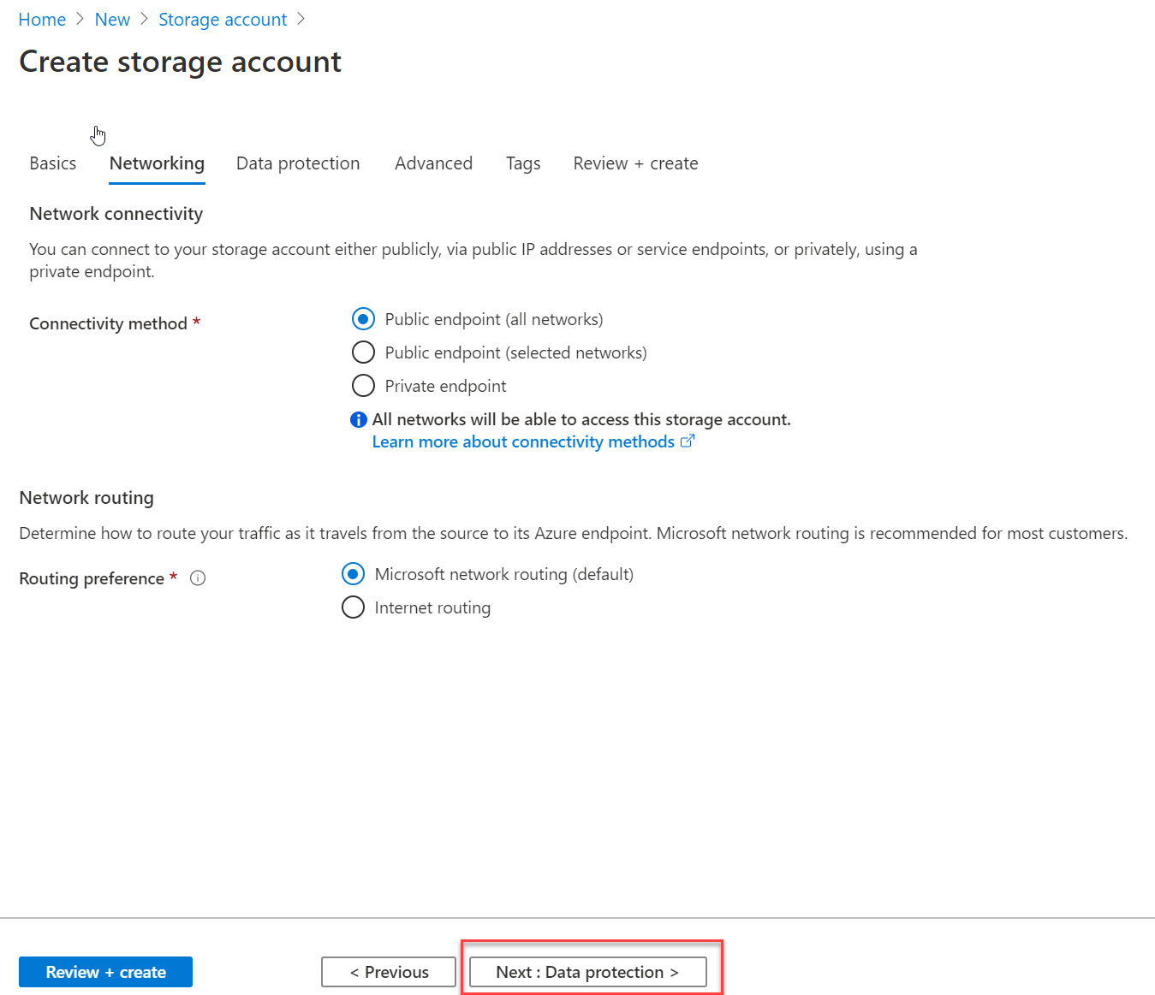

* Keep the Data protection also as default.

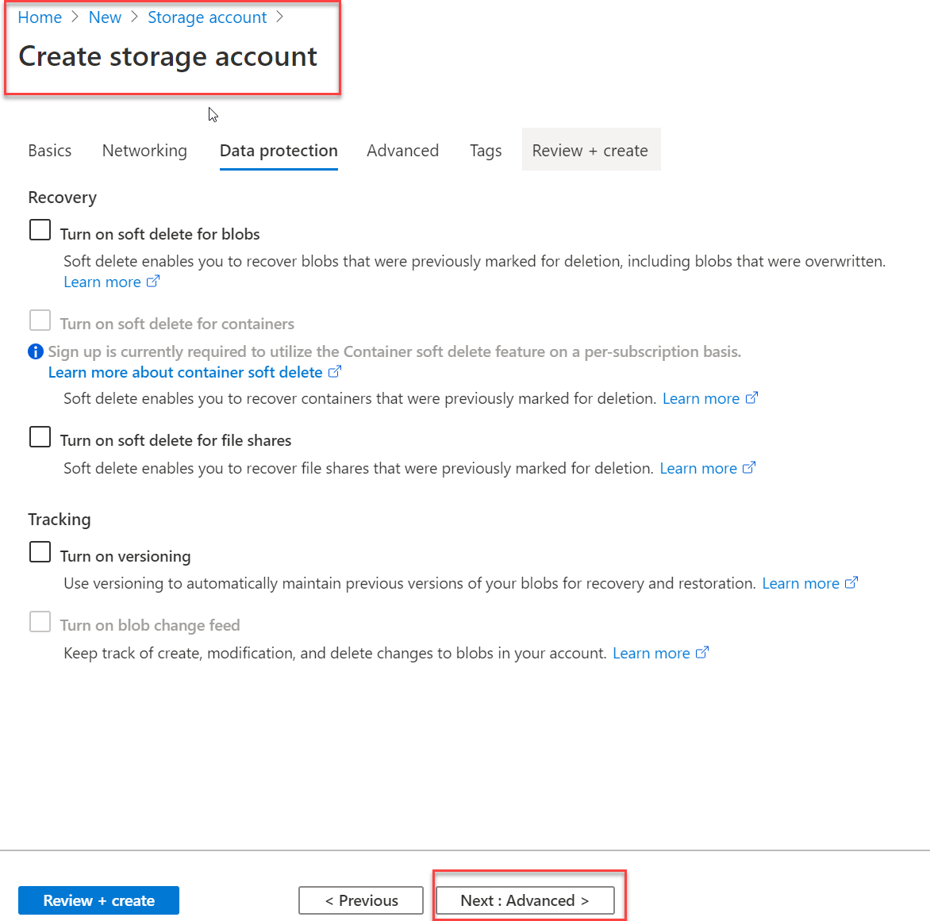

* In Advanced -> Data Lake storage Gen2 change the Hierarchical namespace to Enabled. Click Reviews + Create.

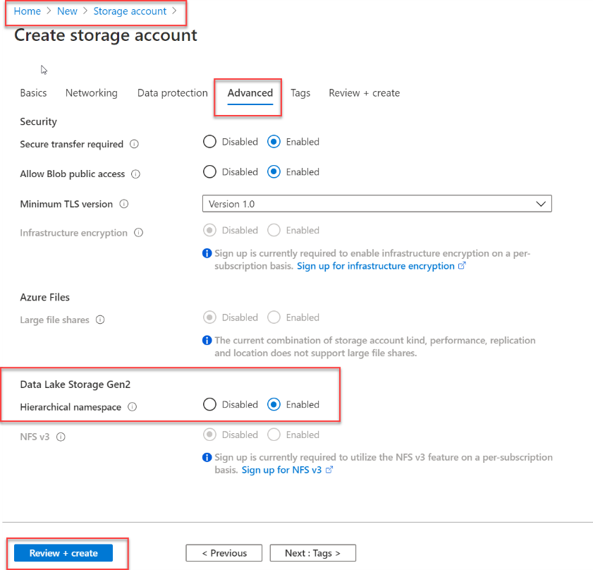

* From the summary, click on create.

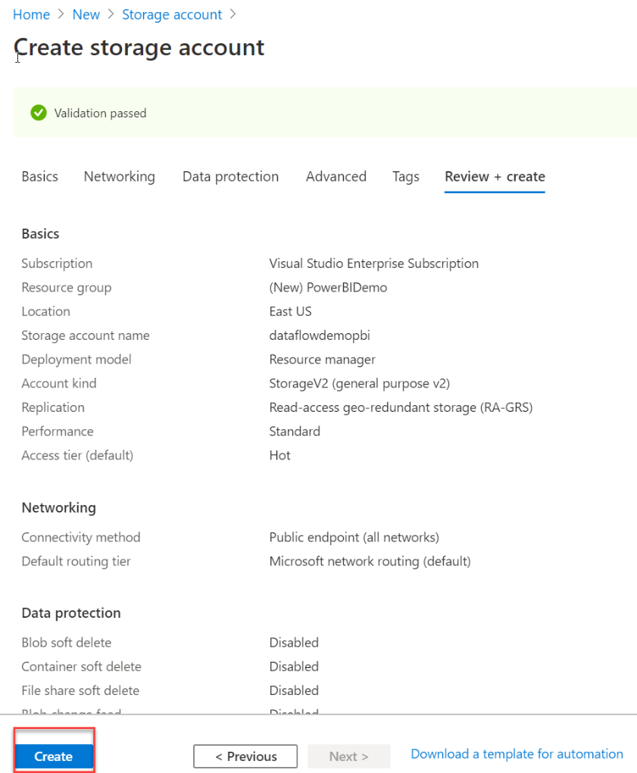

* After the resource is created, notifications should show a dialog with deployment succeeded. Click on Go to resource.

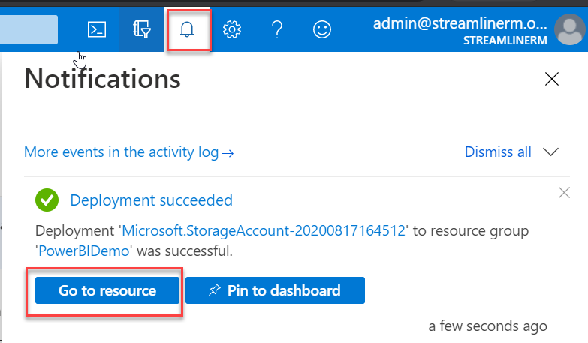

* The overview page should show us the detail about the storage account.
* Click on IAM (Access Control) from the left.

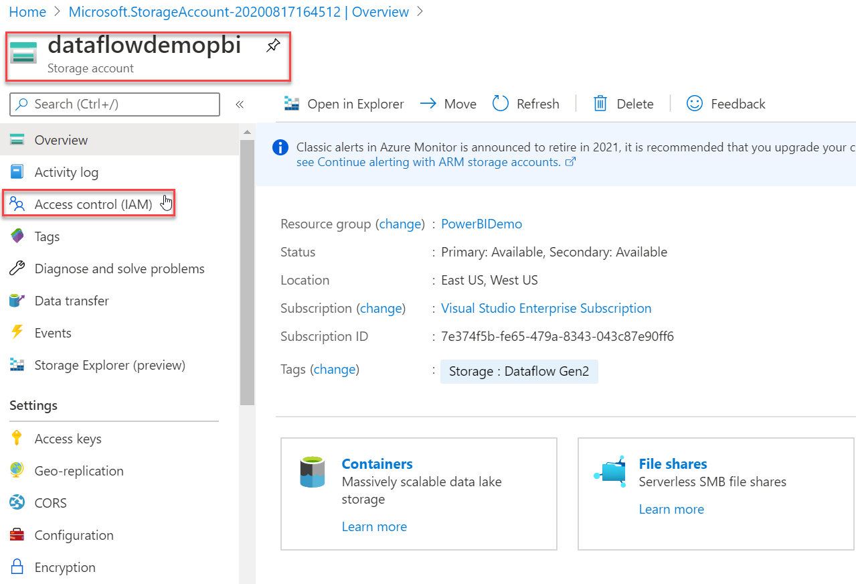

* Click on Add a role assignment.

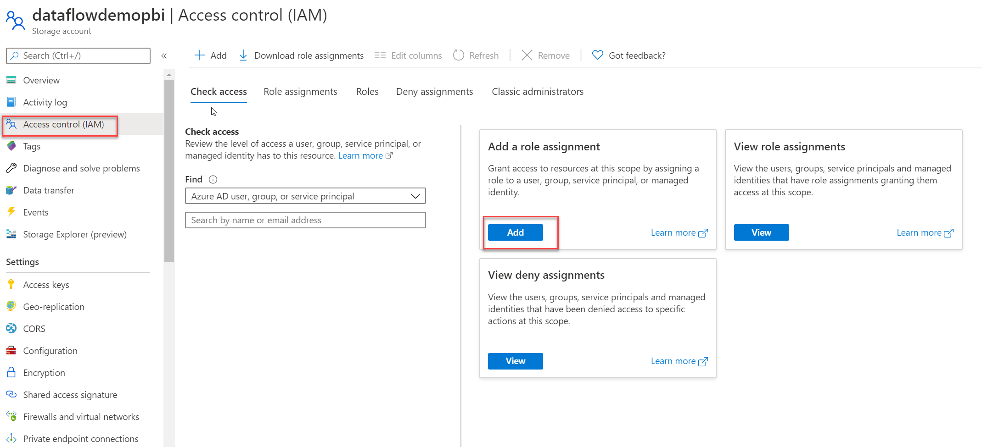

* Make sure you have added the login you have used to create this Storage account. The Role needs to be Owner and the account in my case was [admin@streamlinerm.onmicrosoft.com](mailto:admin@streamlinerm.onmicrosoft.com)

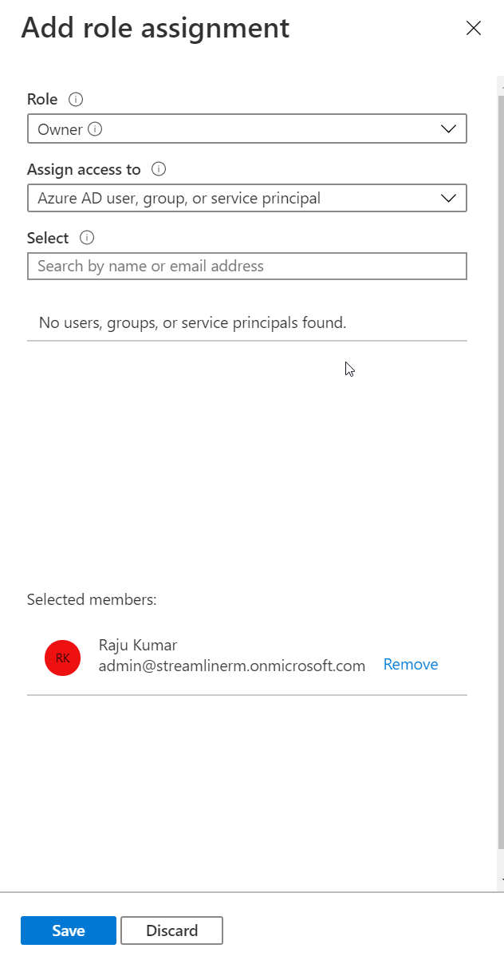

* Click on Add a Role Assignment again, this time from the role drop down select “**Reader and Data Access**” role. For Users, search for Power and select Power BI Premium and Power BI Service.

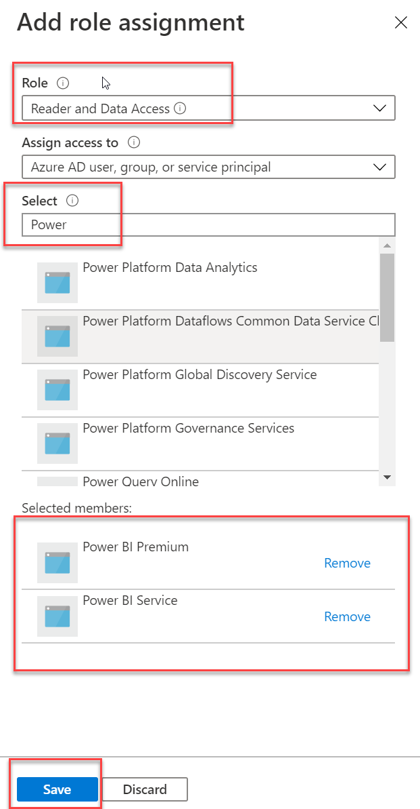

* Click on Add a role assignment again. This time from the Role select **Storage Blob Data Owner** and from user add Power BI Premium and Power BI Service again.

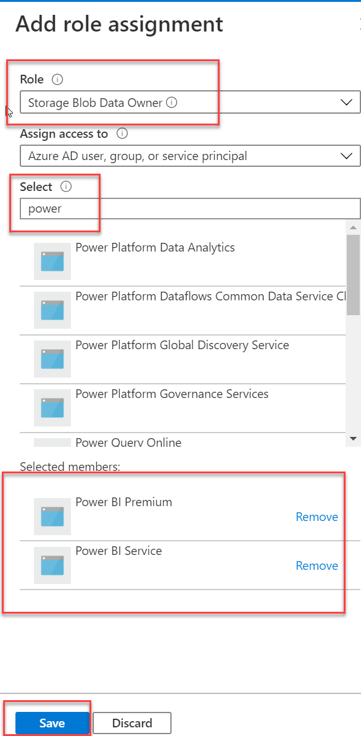

* From the IAM Page you can switch to Role Assignments and see all the permission.

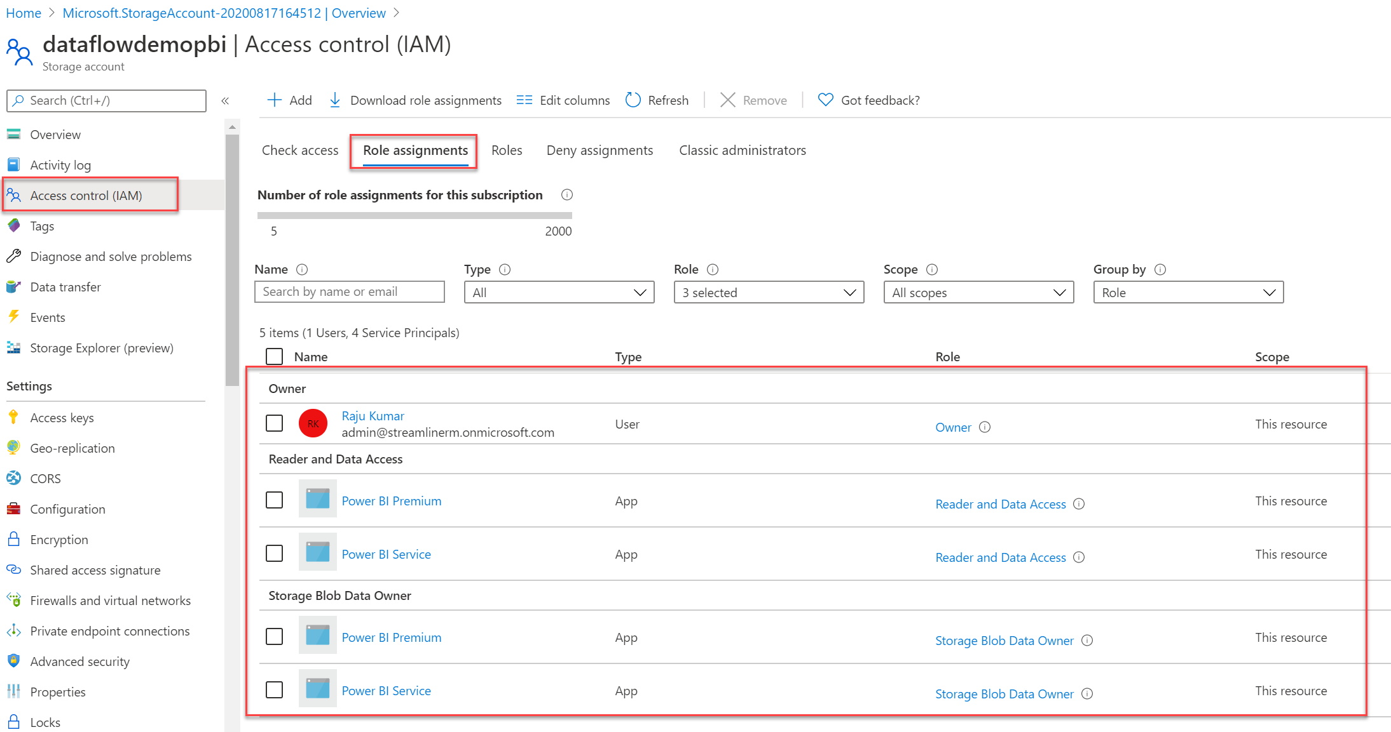

Another resource for Direct query which we need is Power BI Embedded capacity. For this demo I will create Power BI Embedded capacity.

* Go to create a new resource from Azure portal and search for Power BI and select Power BI Embedded.

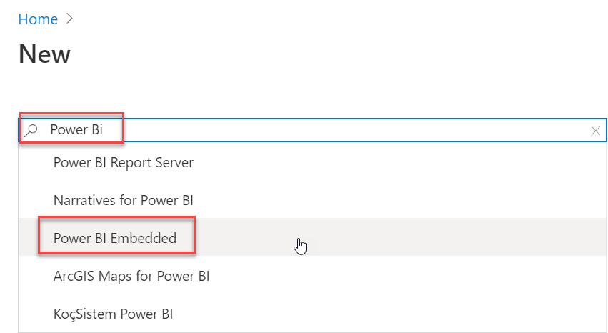

* Click on Create from the following screen.

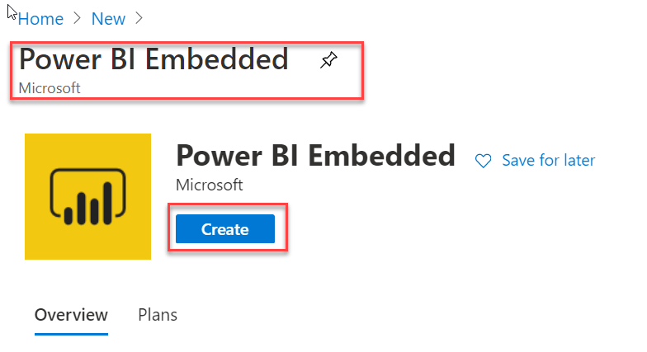

* Specify the basic information, such as name of the resource and Size. We need **A3** and above SKU for Enhanced compute engine to be enabled. For this demo I choose A3.

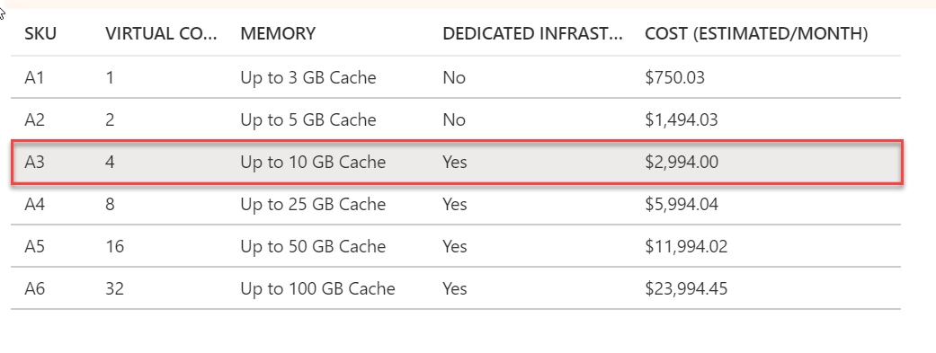

* Once you see Notification showing Deployment is complete, click on Go to Resource.

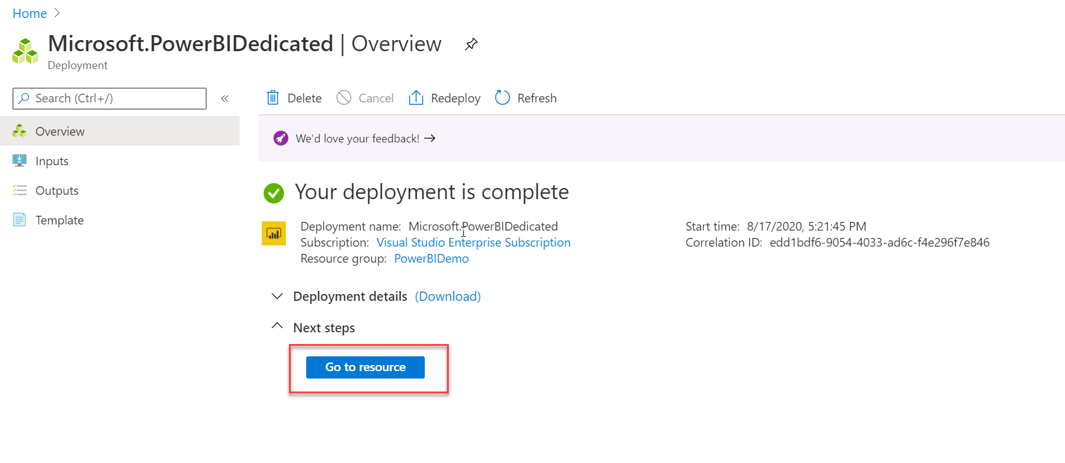

* Notice that we can pause the capacity if we are not using it, this will save us the cost as we are only limited to 150$ a month with Visual studio subscription. (Ignore the screenshot where SKU shows as A2)

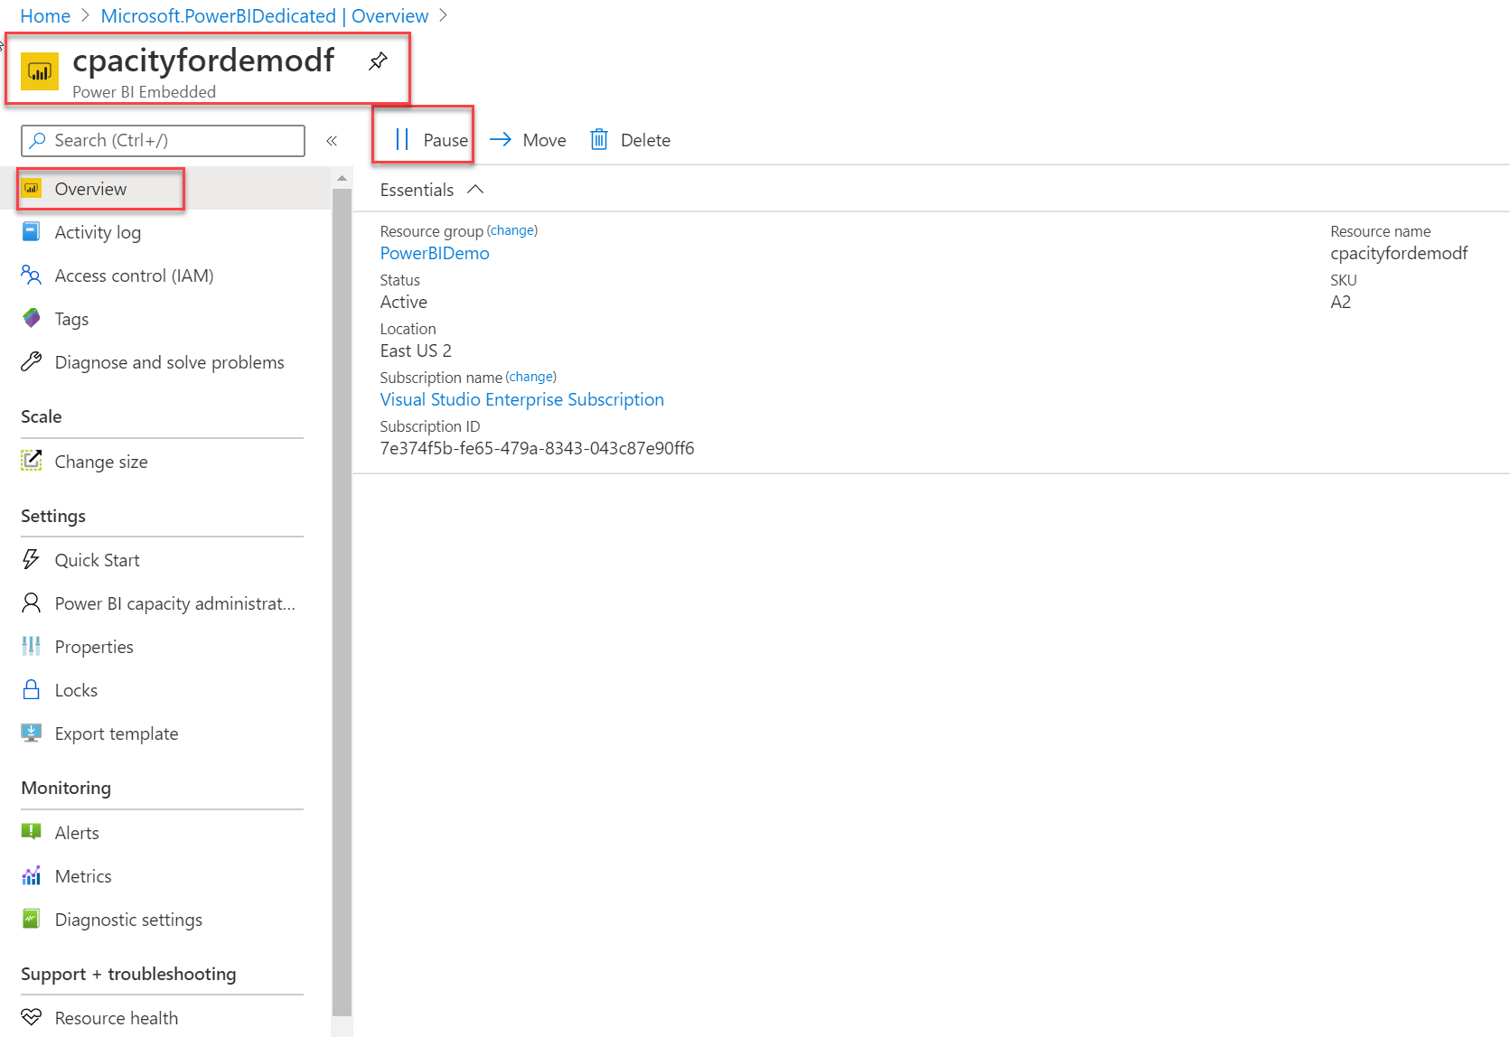

Switch to power BI service now (app.powerbi.com), remember to use the same incognito window / edge Inprivate windows and sign in with same admin account used above.

* Login to app.powerbi.com, from the setting options select Admin Portal.

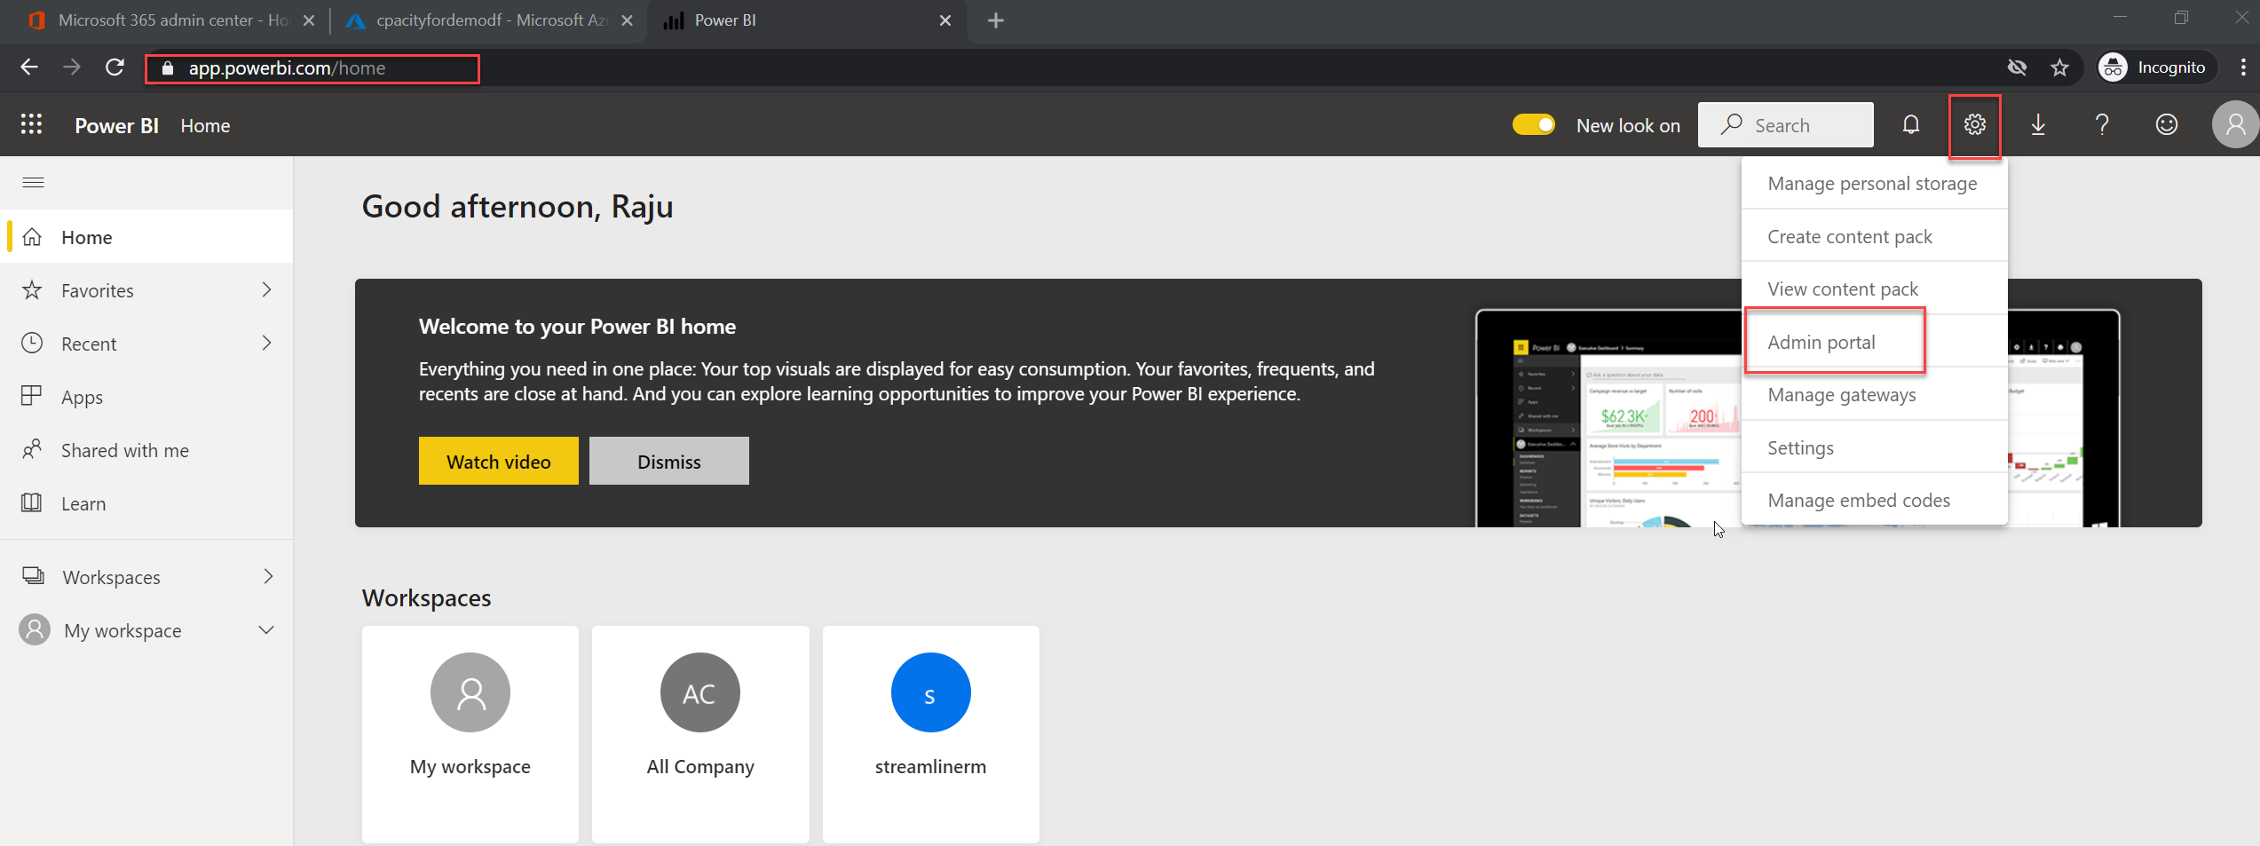

* From the Admin portal page, select Dataflow settings. Click on Connect Your Azure Data Lake Storage Gen2.

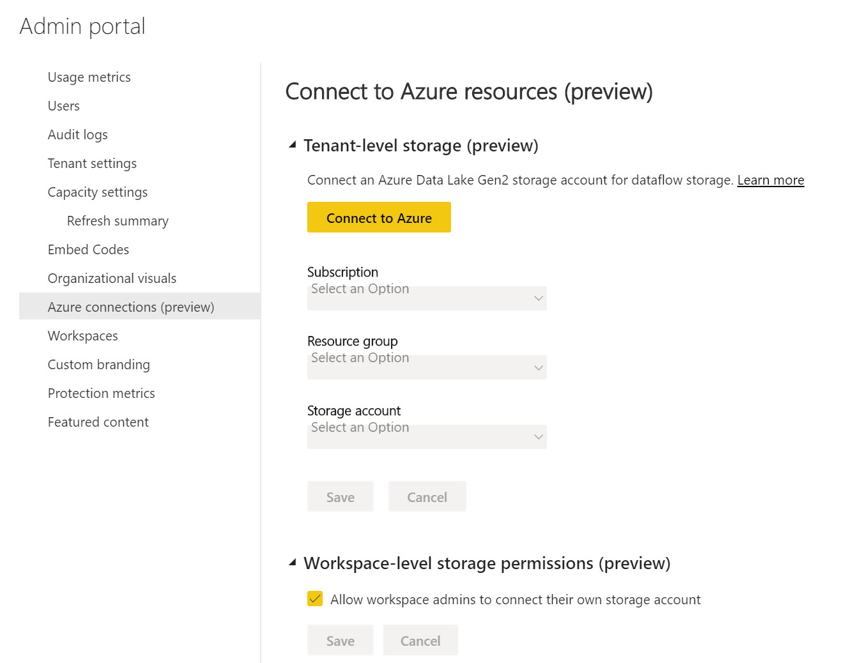

* Use the drop down to choose the subscription and the Storage account created above. After the configuration, the screen should look as follows. I also enabled **Allow workspace admins** to connect, which is not a default configuration.

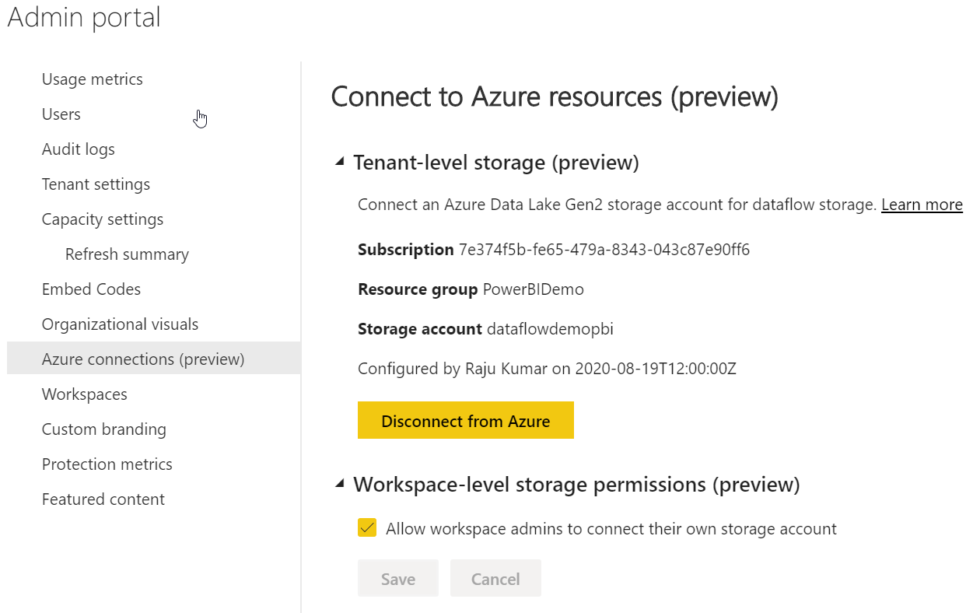

* If you get permission related or region related error, then you missed some steps above. Otherwise you should see the following screen. Some time it does take 10 15 minutes for the changes to reflect as well.
* For this demo, I also enabled Allow Workspace admins to assign workspace to this storage account.
* From Power BI Admin Portal and Tenant setting, ensure we have DataFlow enabled.

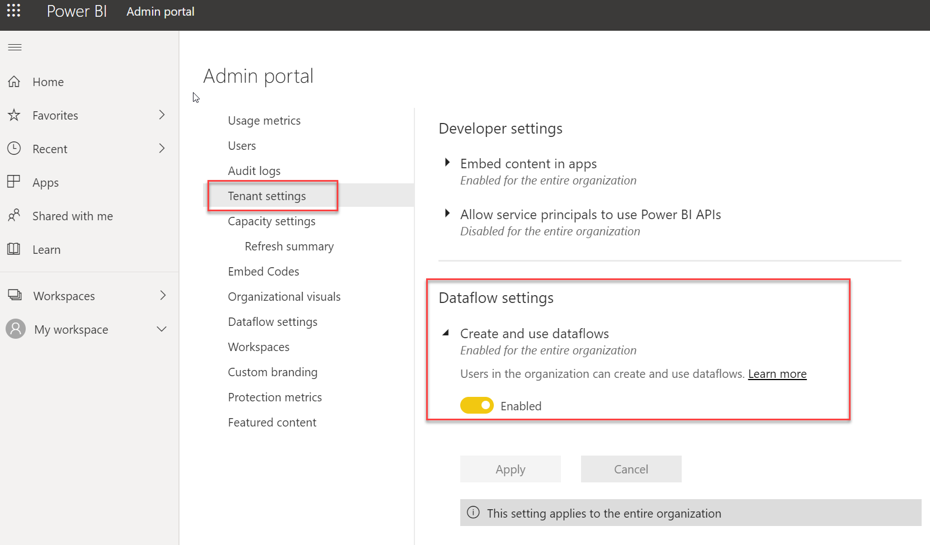

* From Power BI page, switch to Capacity Setting. Ensure we have Dataflow workload enabled.

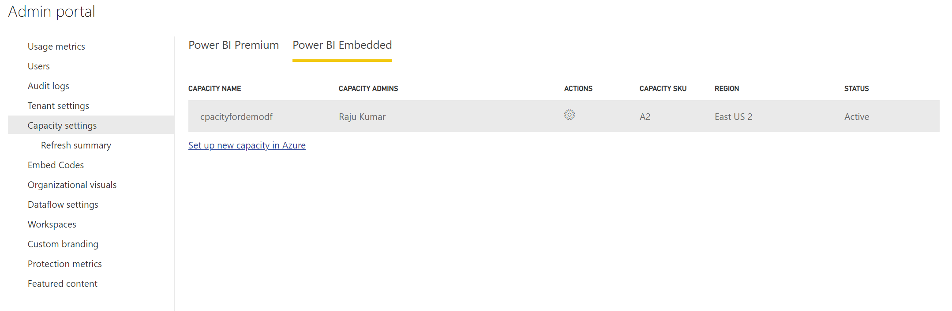

* Click on the Capacity Name. From the Workloads options, scroll down to see dataflow settings.

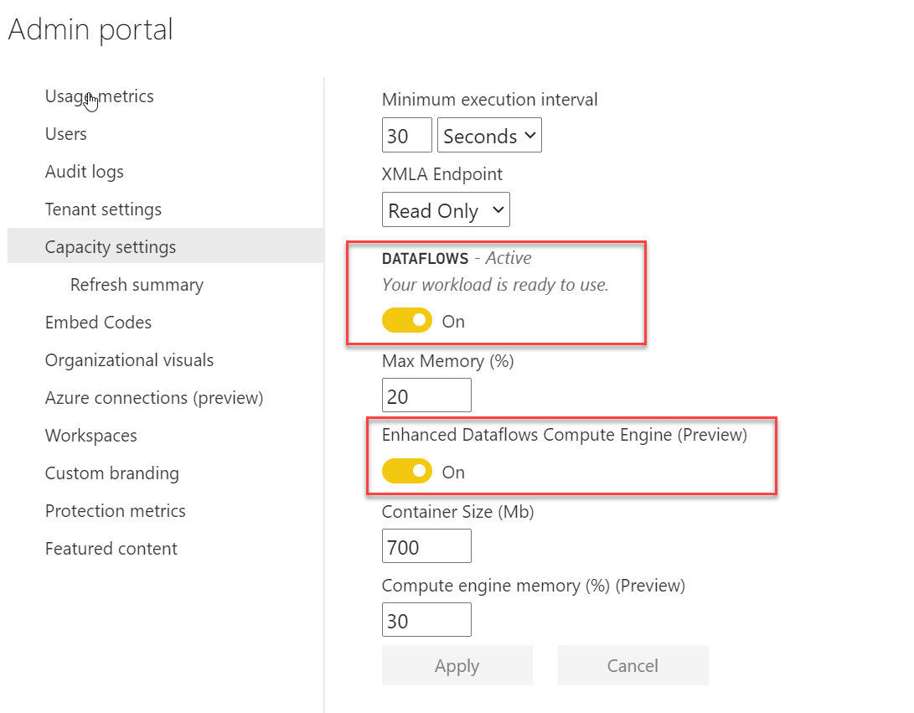

We need to create a dataflow which imports the data and then use that as direct query.

* Create a workspace in PowerBI which is V2 worksapce.

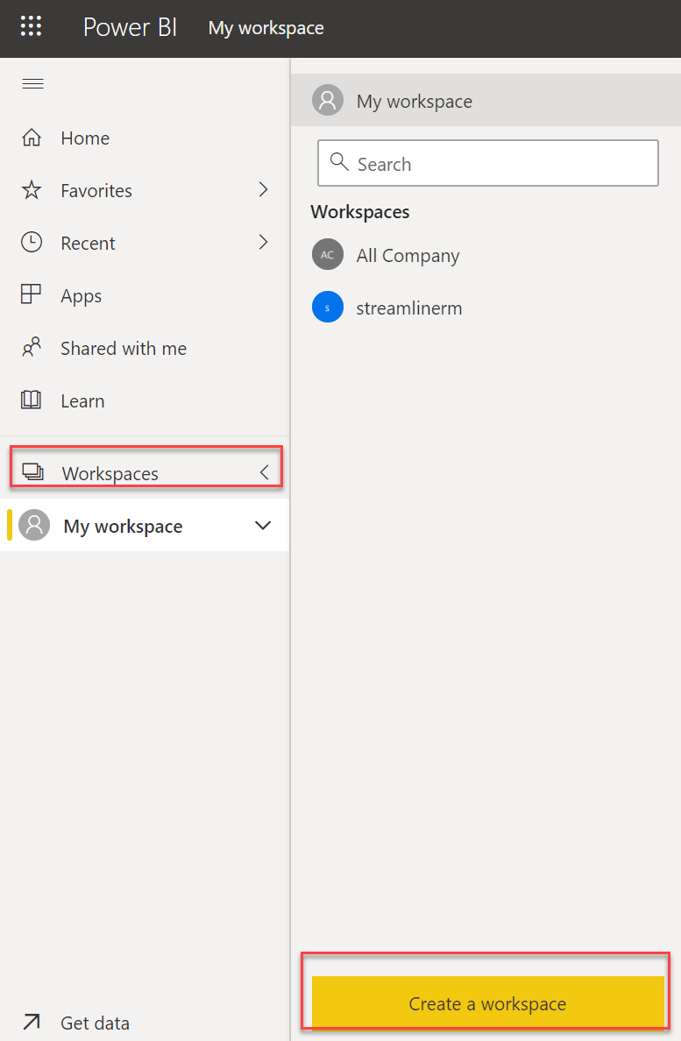

* Specify the name and click on Save. You can also expand advanced and ensure you have premium capacity enabled.

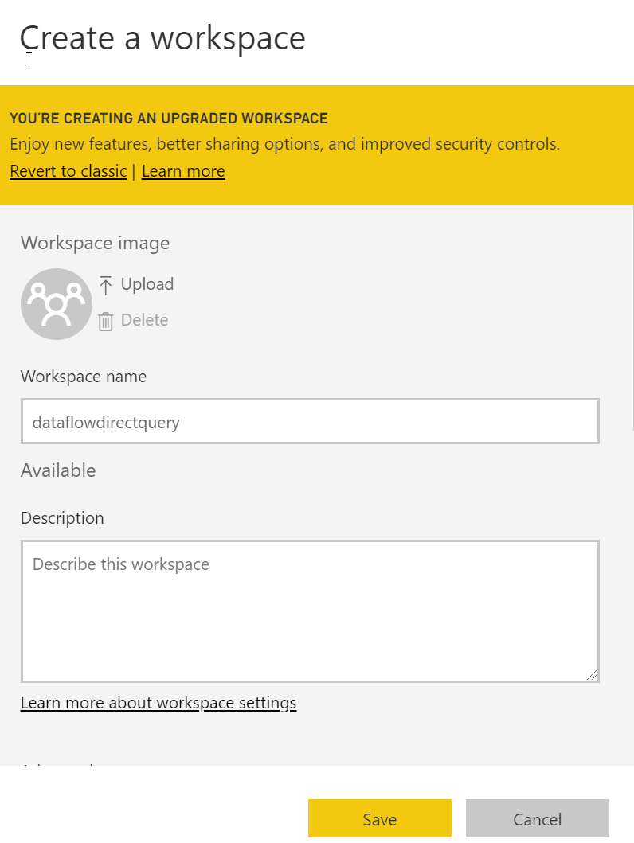

* In my case Premium capacity was assigned when I created the workspace. To make sure that is the case, click on setting once you have the newly created workspace selected.

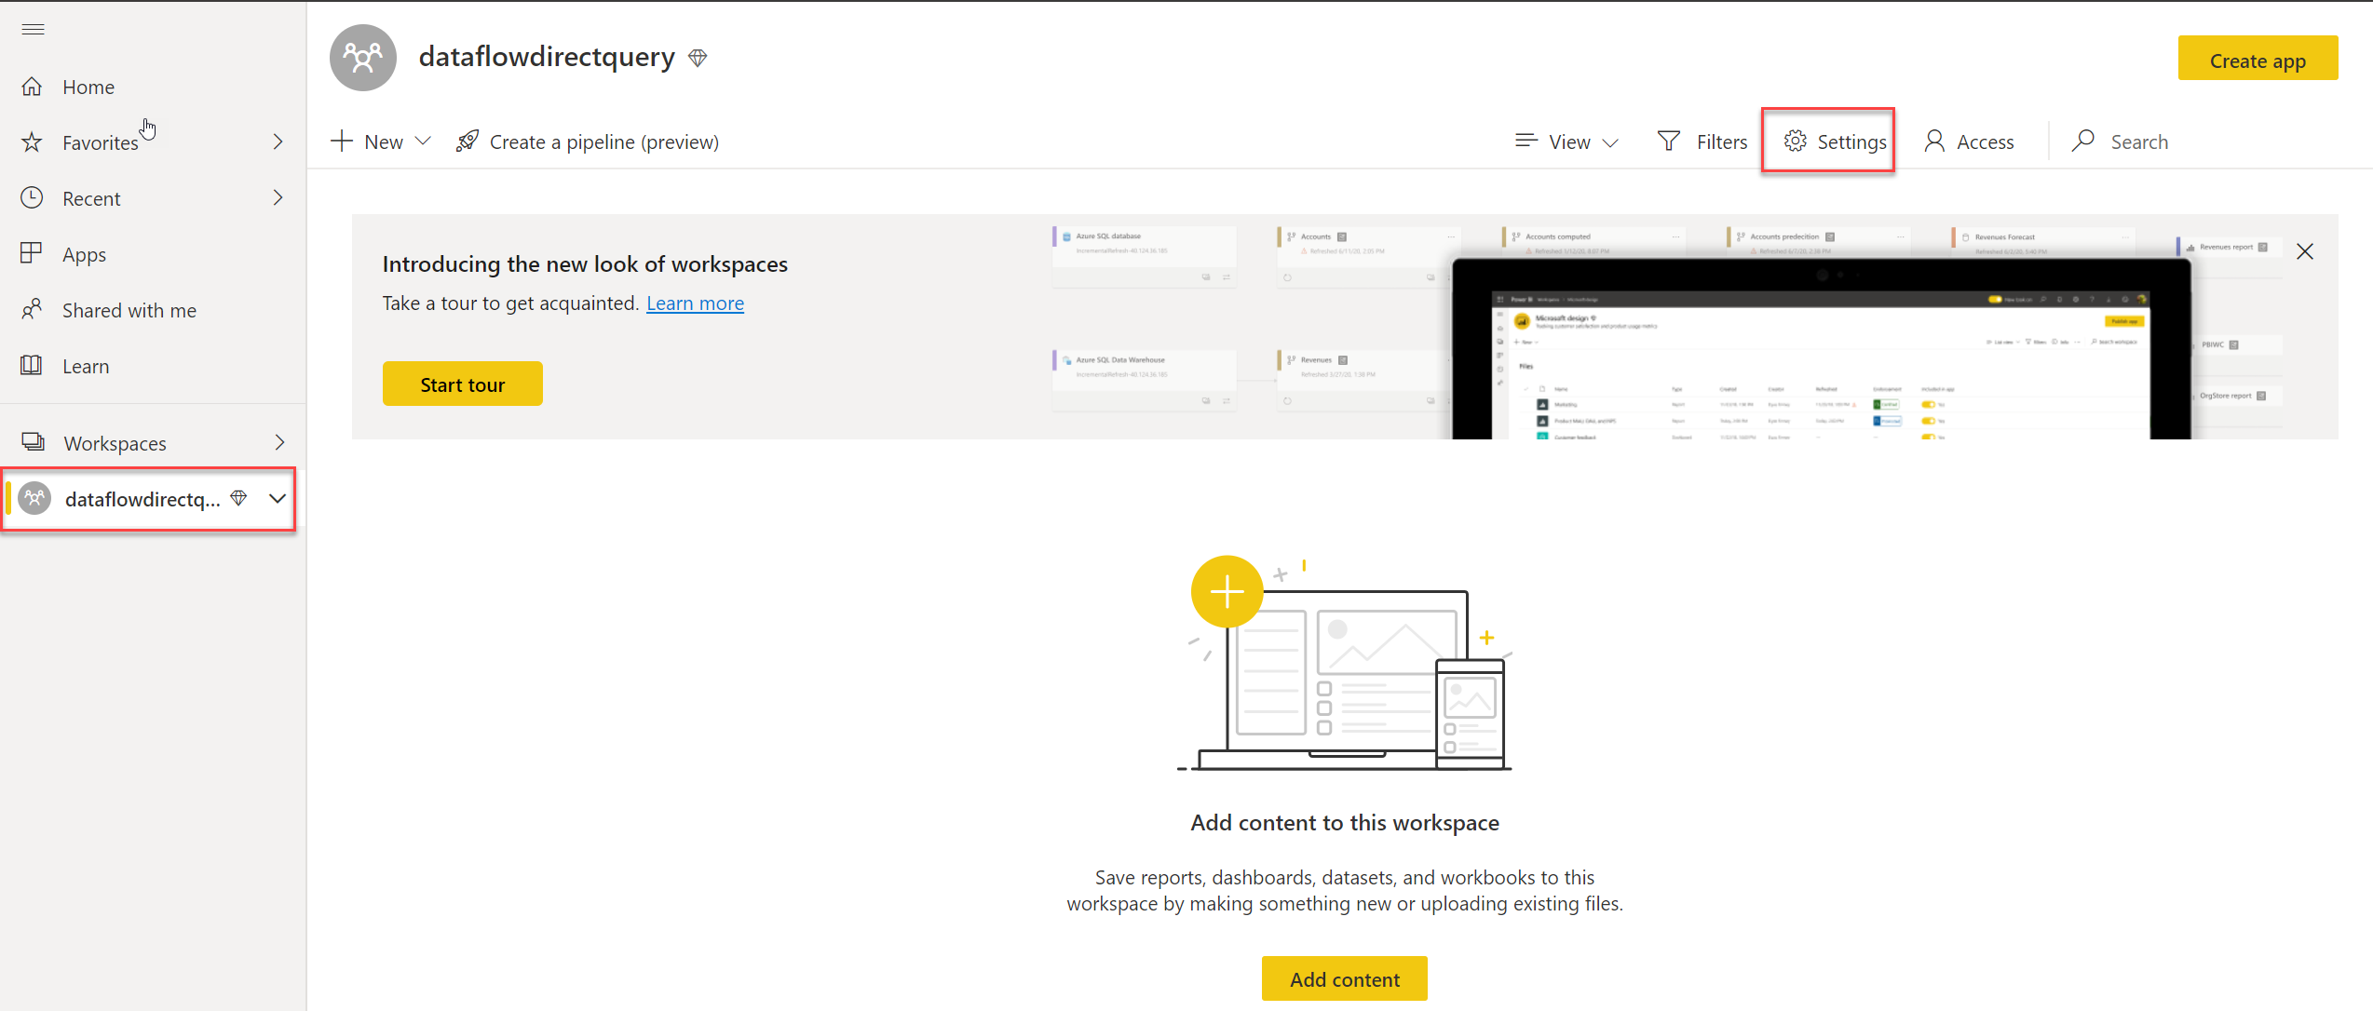

* From the setting option, select the Premium Tab and ensure it is on dedicated capacity. If not, select the option Dedicated capacity and turn it On and click Save.

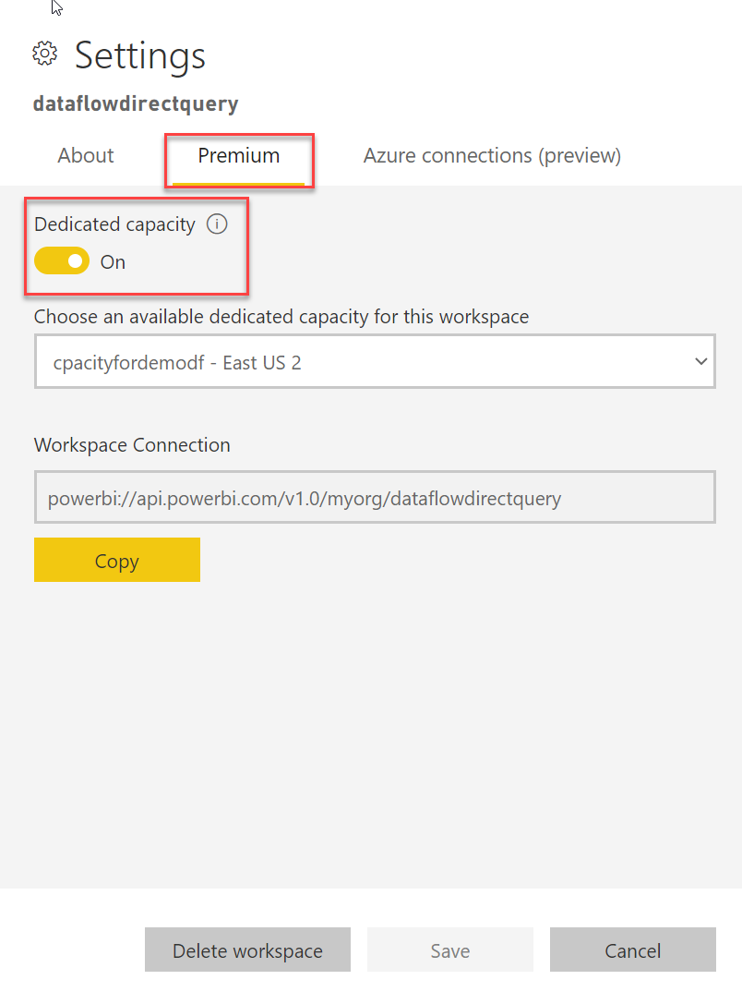

* For this demo, we also need to enable Azure Connections (Preview). From the setting page of the workspace switch to Azure Connections (Preview).

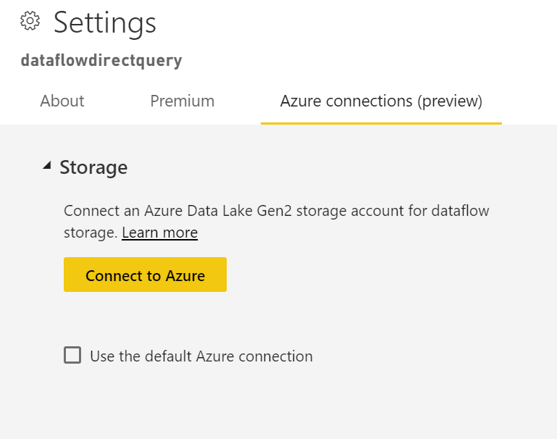

* Click on **Connect to Azure** and specify the detail of the storage account we created previously. I also notice that you can have your own storage account provided the permissions are there and it does work.

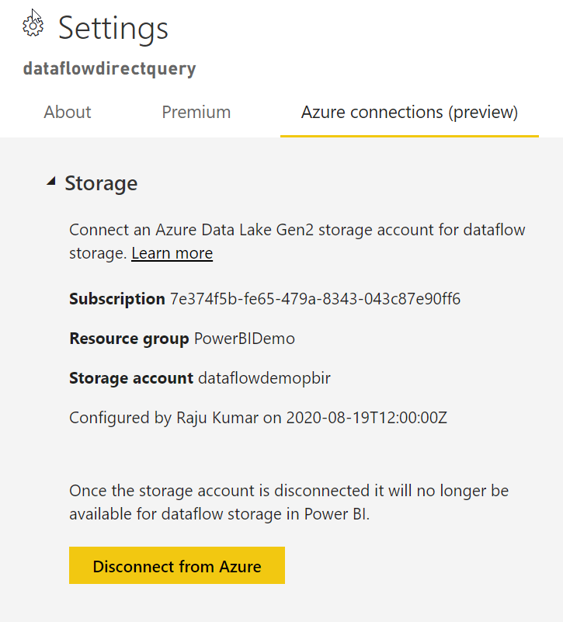

* Now, add an entity in this workspace. Click on New drop down and select Dataflow.

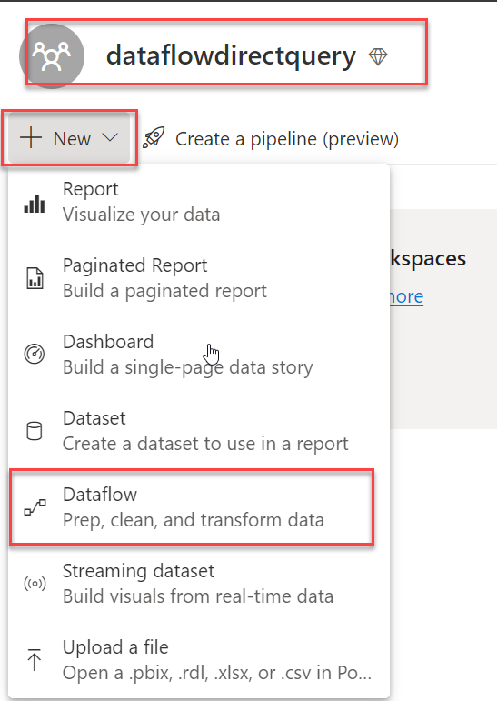

* From the options, click on Import model.

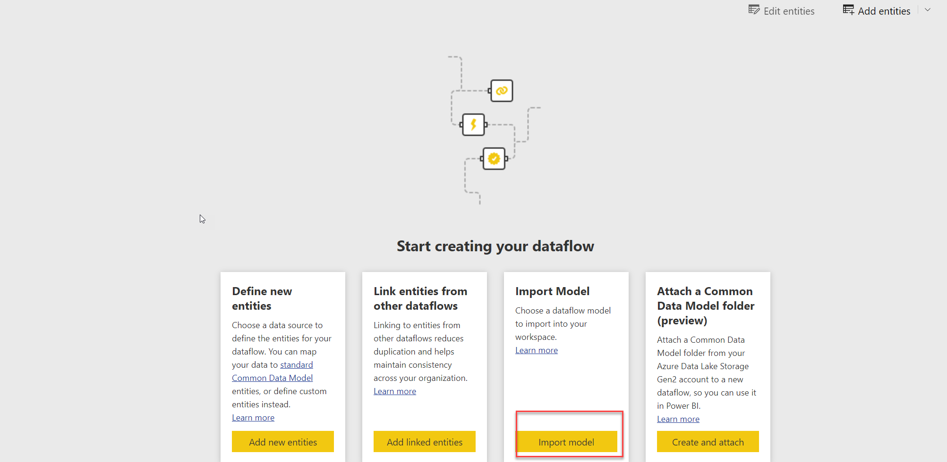

* Use the attached Json file in the File dialog box.



* You may notice few second to import the model.

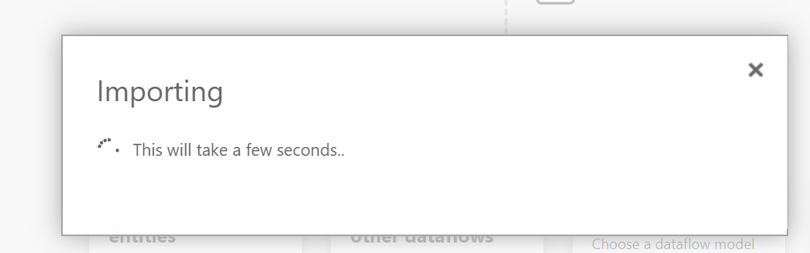

* Click on the new workspace to bring all the content. You would notice a new dataflow imported with a name ResellerSales.

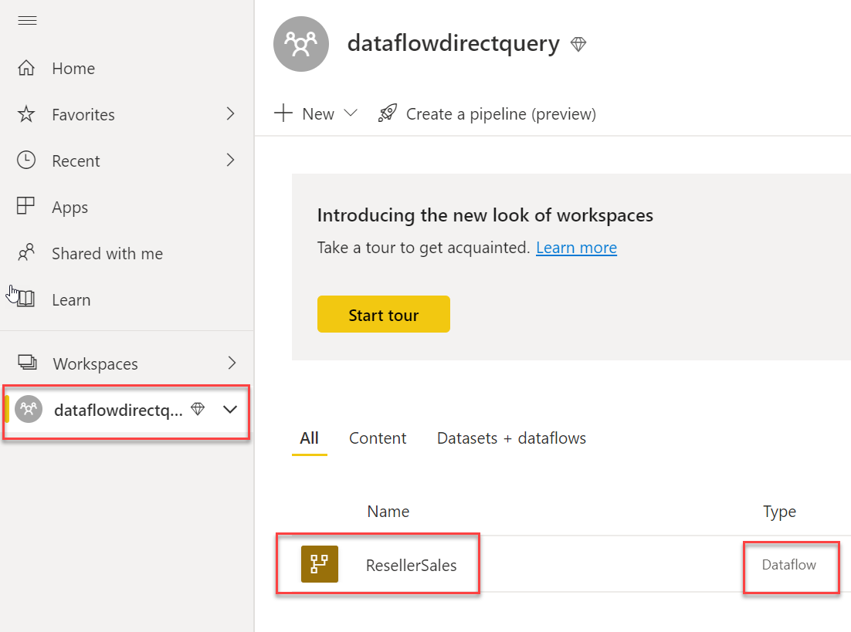

* Highlight the ResellerSales to bring the context menu and select settings.

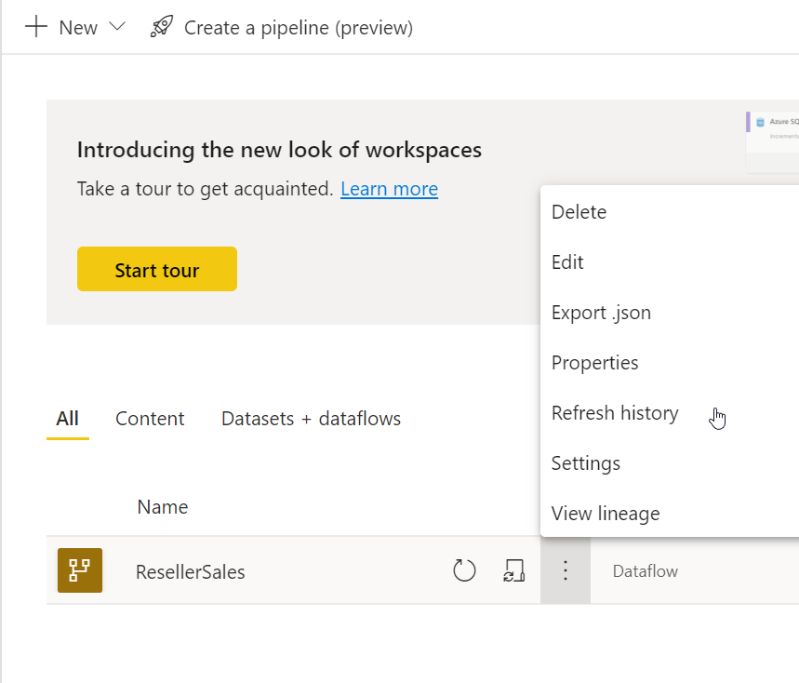

* Expand the data source credentials and click on Edit Credentials.

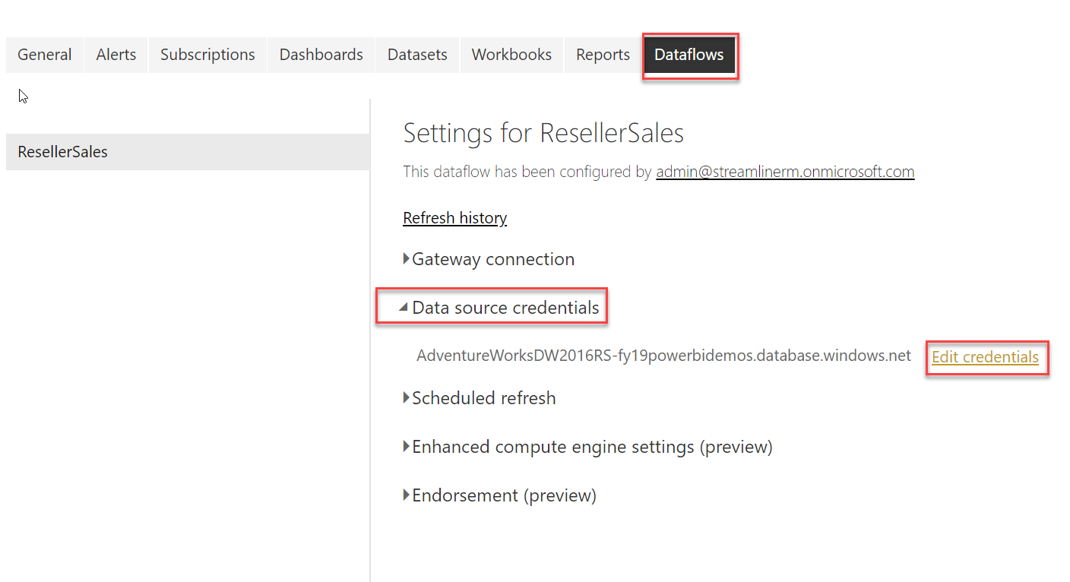

* Specify the following credential. UserName readonlyuser, password as Pass@word1

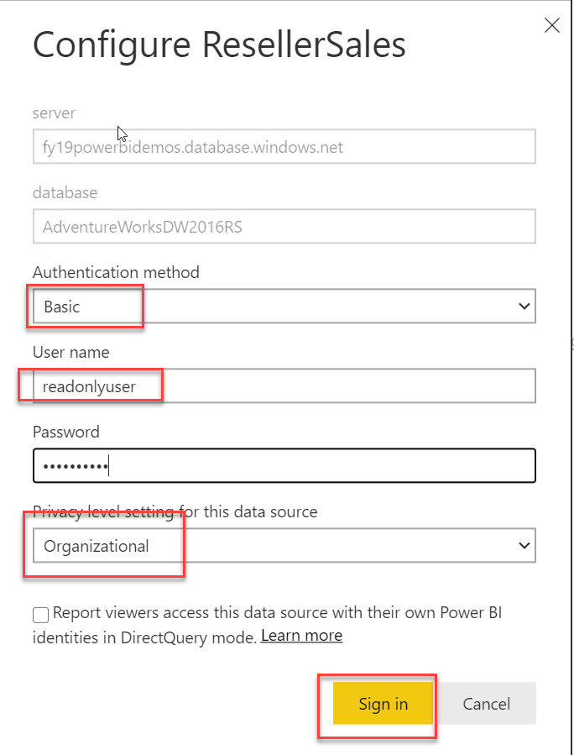

* On the same settings page, expand “Enhanced compute engine settings (preview)”. Change it to On.

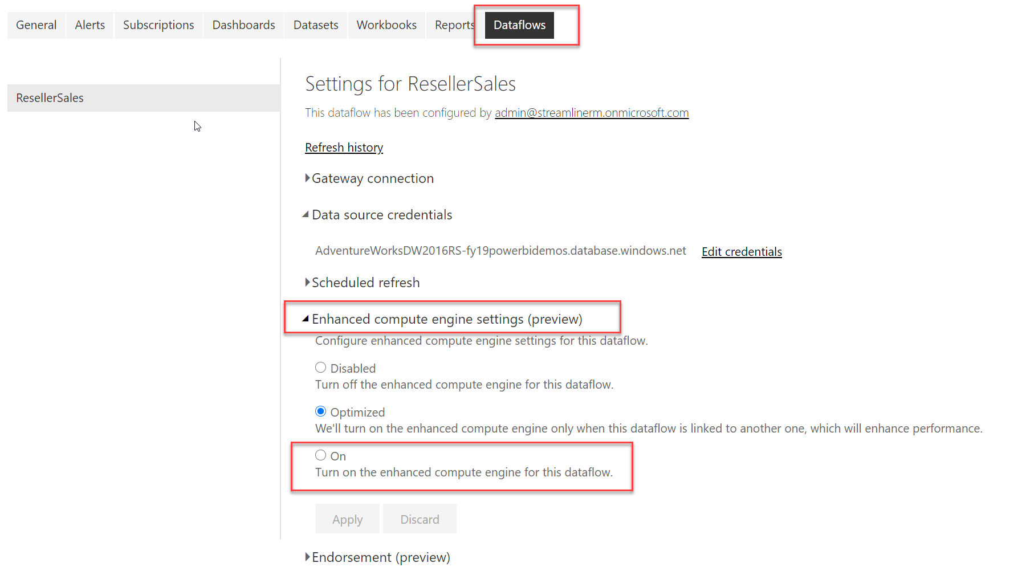

* Click on Apply after making the changes.

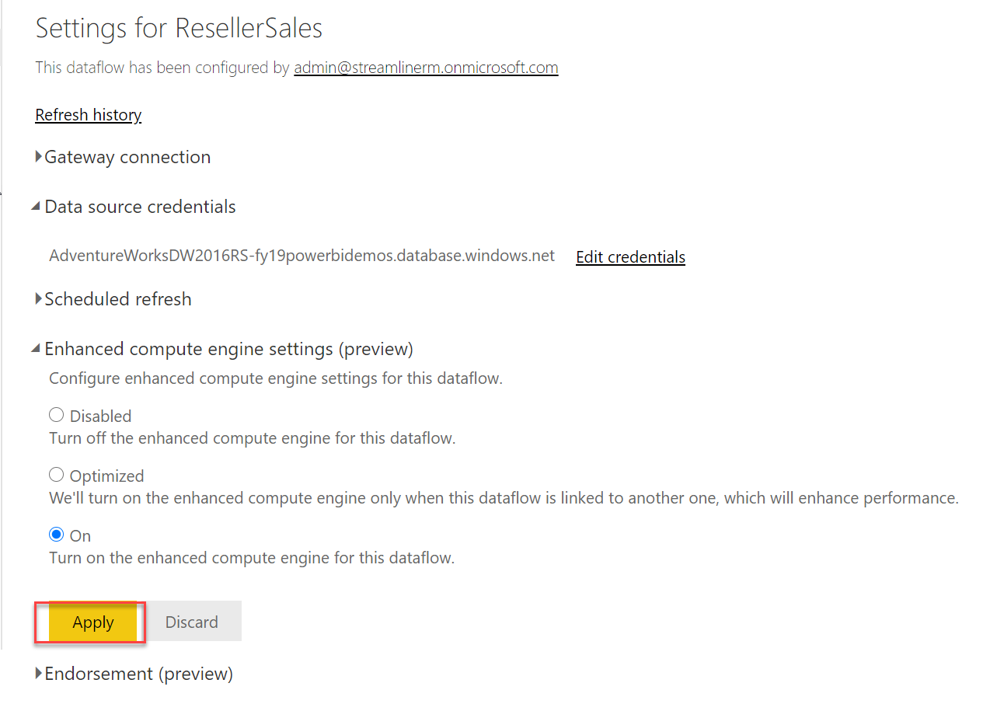

* You will get the following message after the changes is done. This may take few seconds.

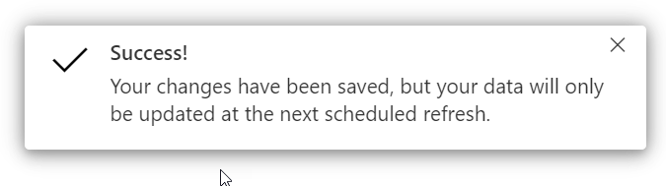

* We need to refresh the dataflow once after this changes. Switch to workspace content and highlights the name Reseller Sales to bring the context menu and select refresh.

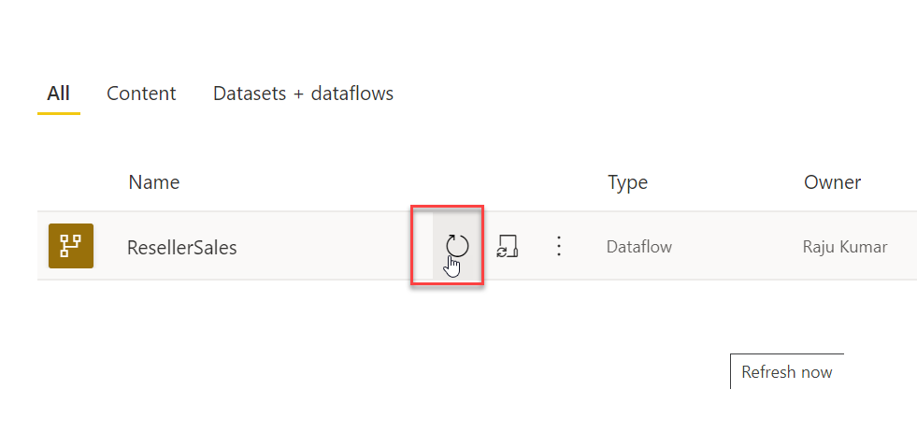

* Click on Setting after initiating the refresh to see the refresh history.

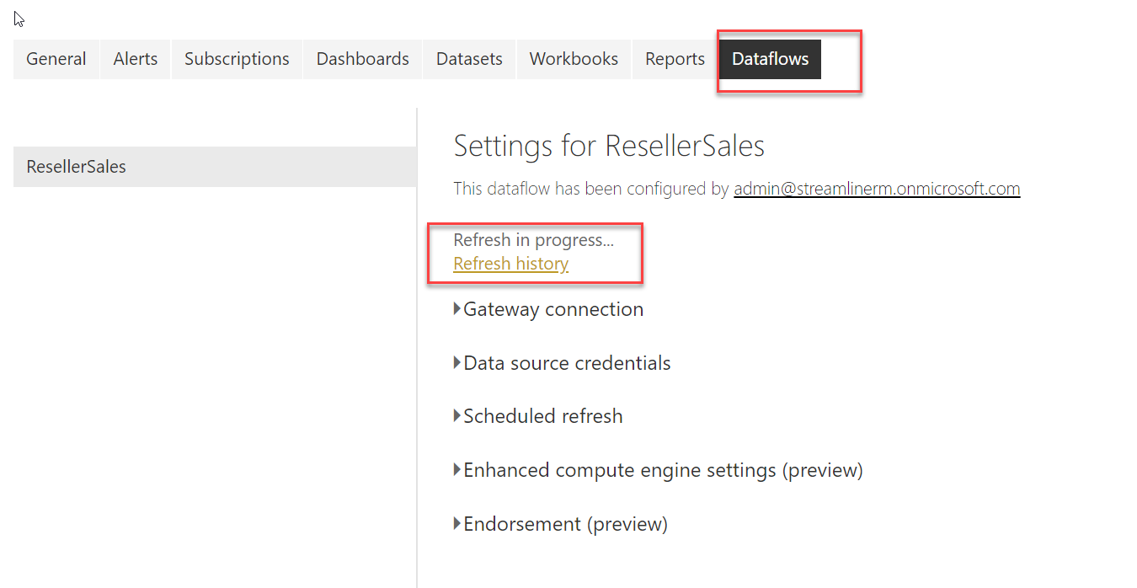

* Refresh history page should look as follows.

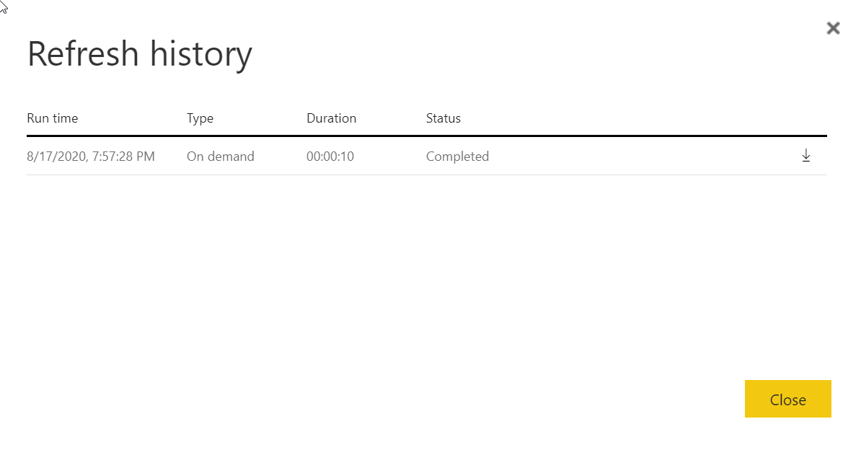

After refresh, open the Power BI Desktop (Not the one which is from Microsoft Store, but the one you install manually from internet).

* After launching Power BI Desktop, I used the same admin account to login.

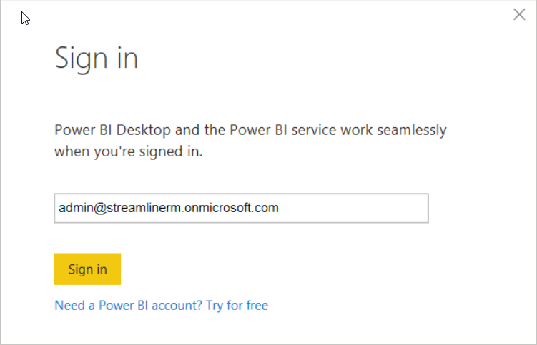

* Go to file menu and select option and settings, choose data source settings.

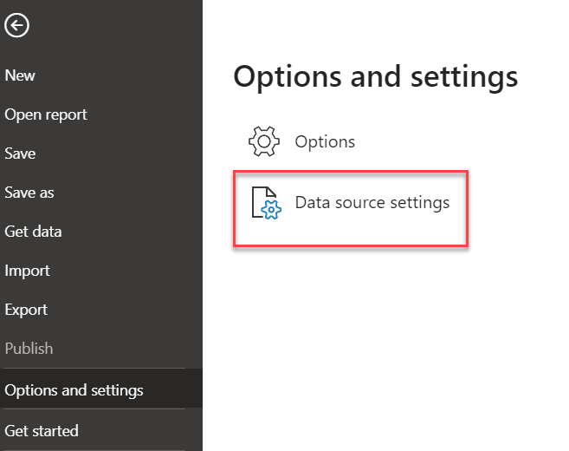

* Clear the permission for Dataflow if it exists.

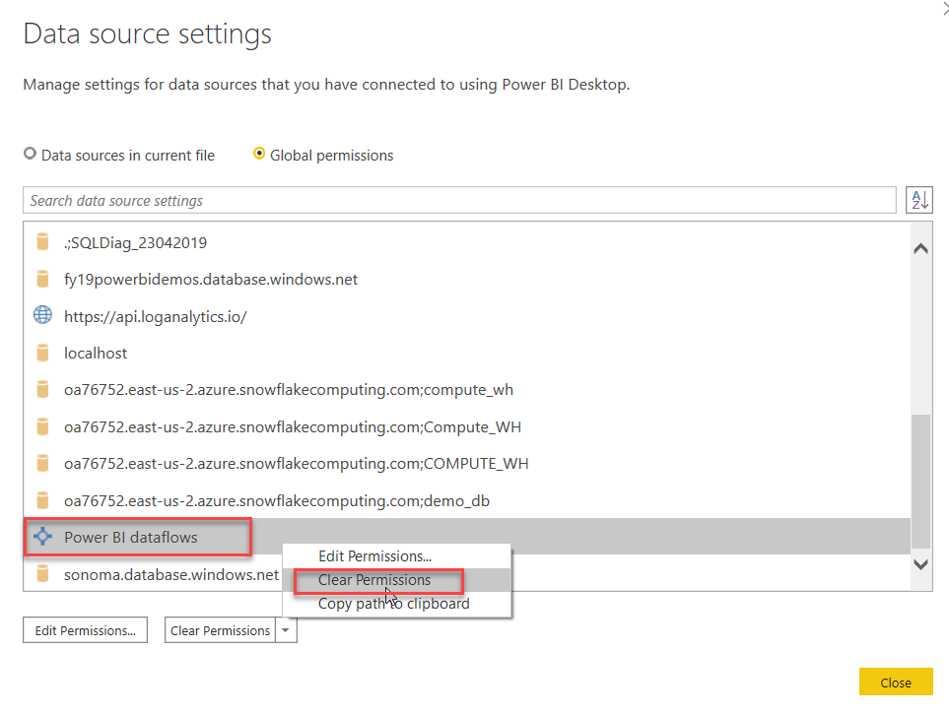

* Click on Get Data -> Power BI dataflows.

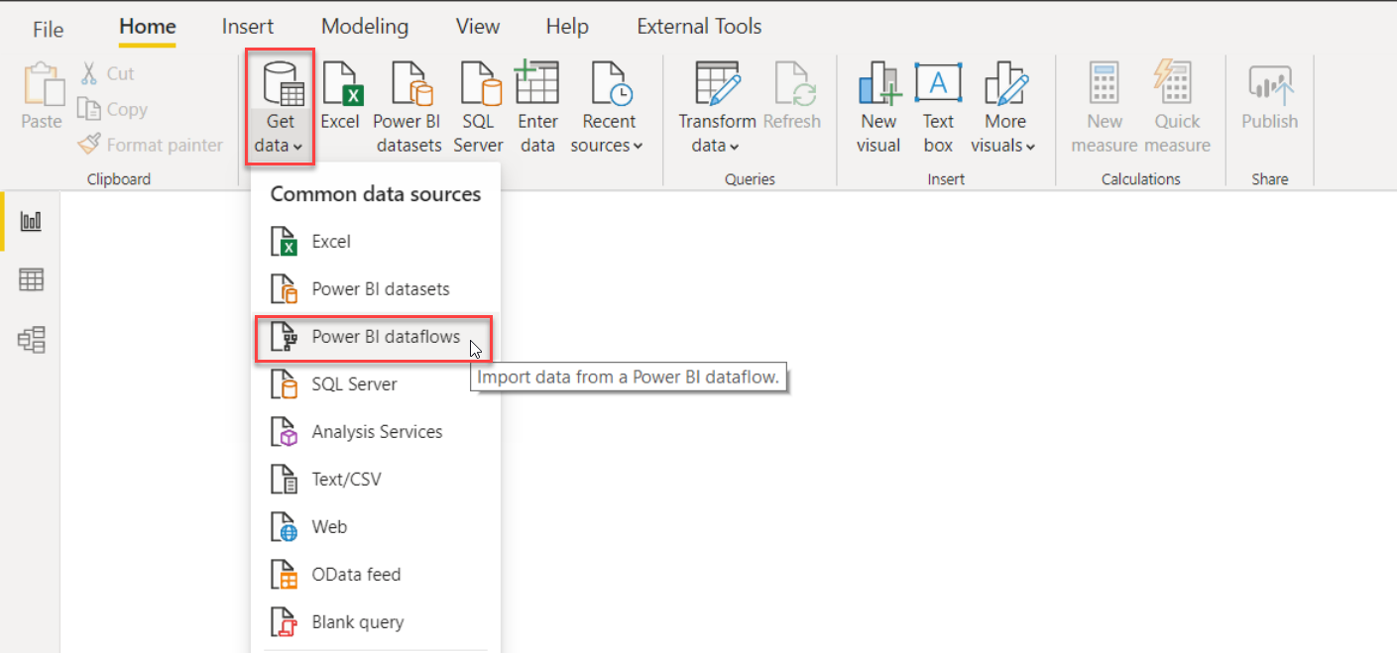

* Sign in using the admin account as above and click on Connect.

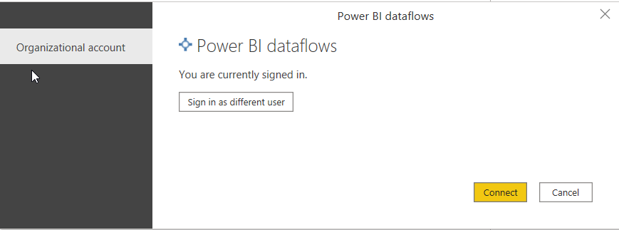

* Expand the ResellerSales we created under dataflowdirectquery workspace, click on Load.

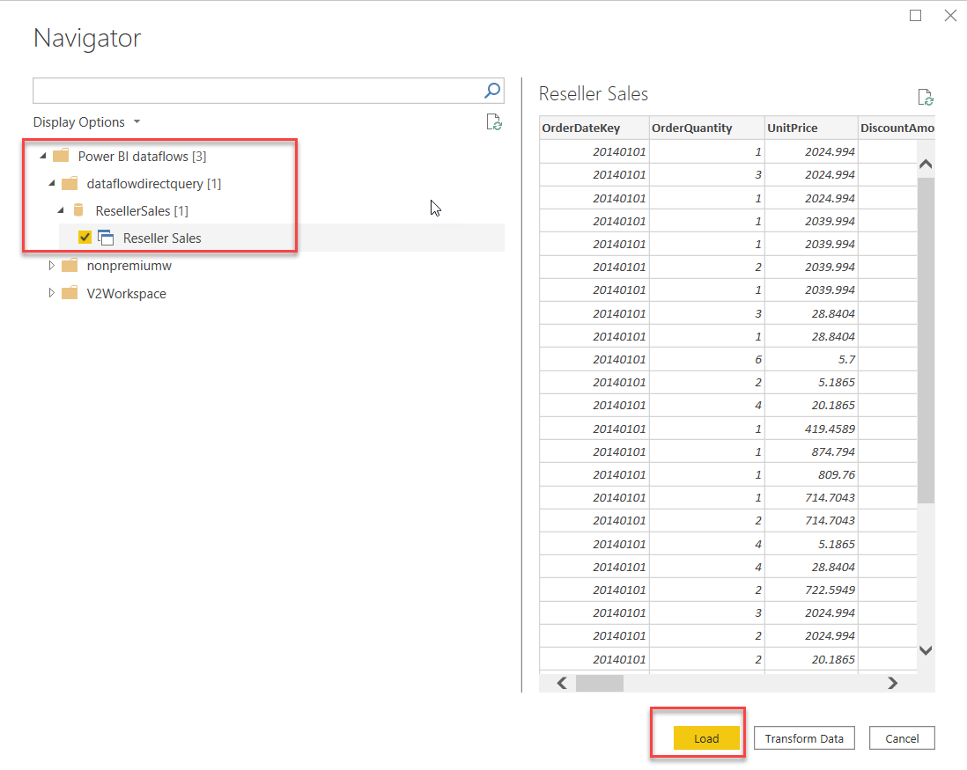

* Once you click load the storage mode setting should be prompted, select DirectQuery and click on Ok.

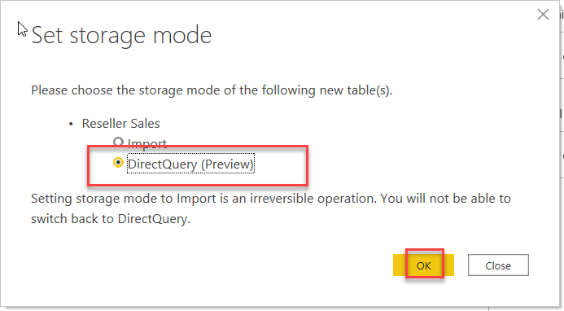

References

<https://powerbi.microsoft.com/en-us/blog/power-bi-dataflows-multiple-data-lakes-support/>